**CS171 Process Book**

Global Health Infrastructure

Nishanth Nayakanti

**Table of Contents:**

* Overview and Motivation:
* Related Work:
* Questions:
* Data: Source, scraping method, cleanup, etc.
* Exploratory Data Analysis:
* Design Evolution:
* Implementation:
* Evaluation:

**Overview and Motivation:**

Motivation of the project is to build a visualization tool to analyze global health infrastructure and a general health indicator like Life Expectancy.

**Questions:**

1. Is overall health (for example life expectancy) correlated to Health infrastructure of country (health spending, Health Personnel, Hospitals)?
2. How did overall health of the countries change over time?
3. How did health infrastructure of all countries change over time?
4. Compare health spending, infrastructure and life expectancy of the countries over time?
5. Which countries have best Hospitals?

* **Data:**

**Source**

1. Health expenditure per capita

<http://data.worldbank.org/indicator/SH.XPD.PCAP>

1. Physicians per 1000

<http://data.worldbank.org/indicator/SH.MED.PHYS.ZS>

1. Hospital Beds per 1000

<http://data.worldbank.org/indicator/SH.MED.BEDS.ZS>

1. Life expectancy at birth:

<http://data.worldbank.org/indicator/SP.DYN.LE00.IN>

1. Best Hospitals in the world (Academic point of view)

<http://hospitals.webometrics.info/en/world>

**Scraping method:**

The below 4 modules doesn’t need any processing, they are well formatted datasets available at <http://data.worldbank.org>

1. Health expenditure per capita
2. Physicians per 1000
3. Hospital beds per 1000
4. Life expectancy at Birth
5. GDP per capita

5. Best Hospitals in the world:

Hospital ranking data is scraped from a website. I implemented data scraping/processing in **Python and BeautifulSoup**

<https://github.com/nishanthDS/cs171-pr-GlobalHealthInfrastructureAndMedicalTourism/tree/master/data%20scraping>

Here is the sample data (/data/Hospital_Rank.csv)

|  |  |  |
| --- | --- | --- |
| **Rank** | **Hospital** | **Country** |
| 689 | Bermuda Hospitals Board | Bermuda |
| 26 | Alberta Health Services | Canada |
| 98 | Hospital for Sick Children | Canada |
| 109 | SantÌ© MontÌ©rÌ©gie | Canada |
| 113 | Centre for Addiction & Mental Health | Canada |
| 133 | Vancouver Coastal Health | Canada |
| 144 | London Health Sciences Centre | Canada |
| 177 | University Health Network | Canada |

**Data Structure**

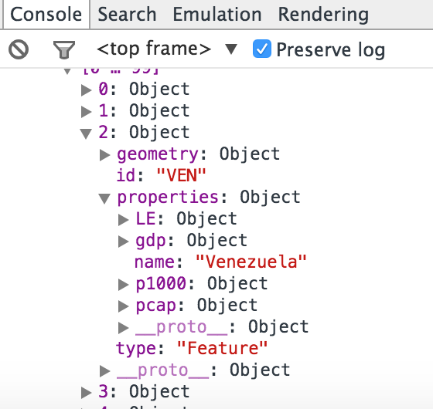

Each Object represents a Country.

* Geometry: data of geojson for choropleth map
* LE: Life expectancy data for each country for all the years
* Gdp: GDP per capita income for all the years
* P1000: Physicians per 1000 people for all the years
* Pcap: Per capita health spending for all the years.

**Exploratory Data analysis:**

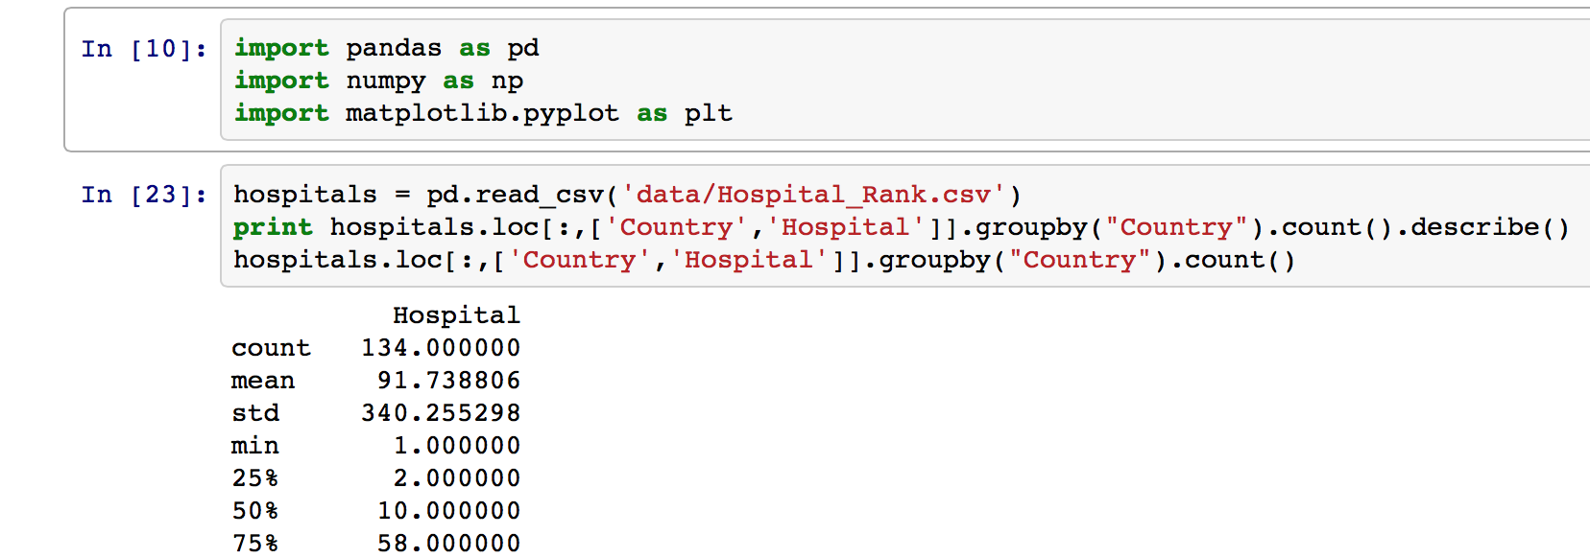

* **Design Evolution**

**Design choice 1:**

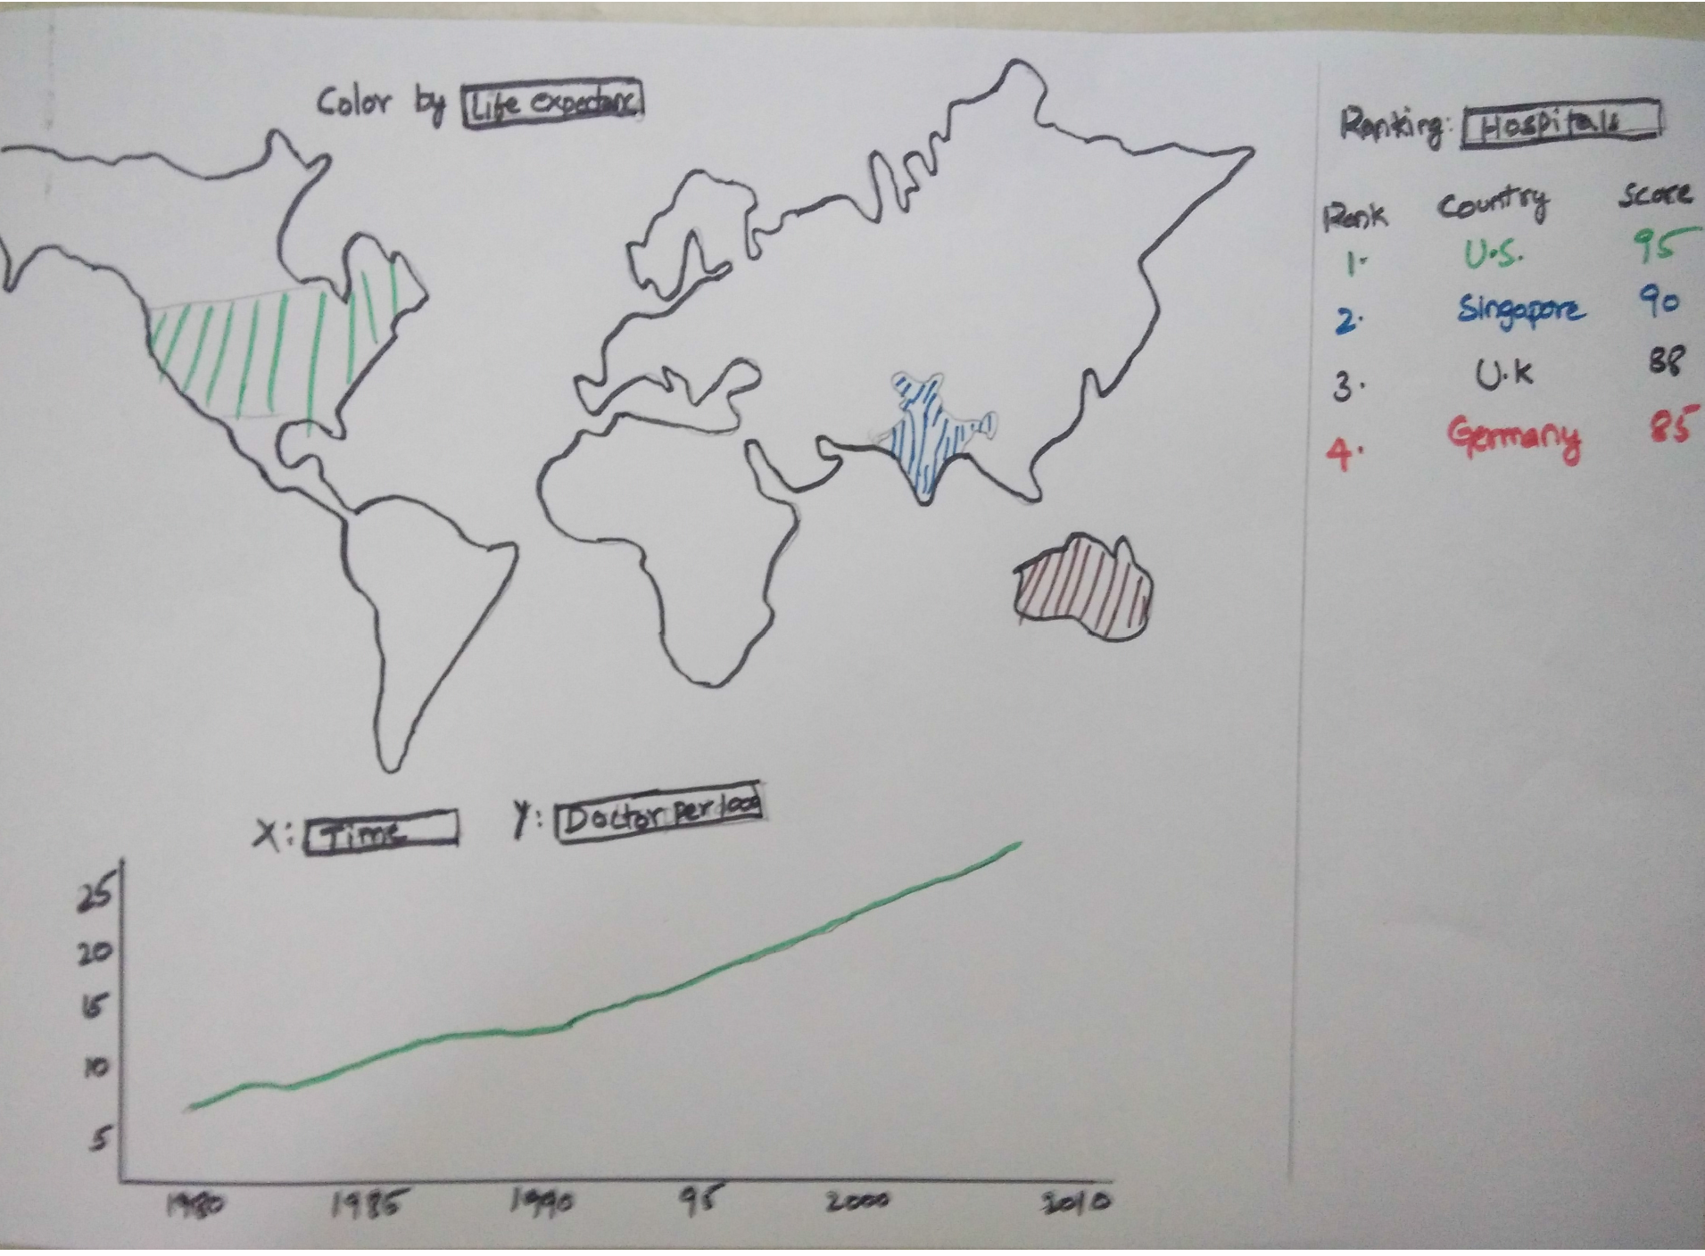

1. Choropleth map with color coding on top
2. Line graph with **year/time** onXAxis on bottom
3. Ranking of countries based on top hospitals on right

**Cons:**

**Line graph with year/time on Xaxis and parameters like (Life Expectancy, Pcap health spending, Physicians per 1000):**

All the indicators/parameters will increase with time, there is not much to visualize or analyze

**Design choice 2**

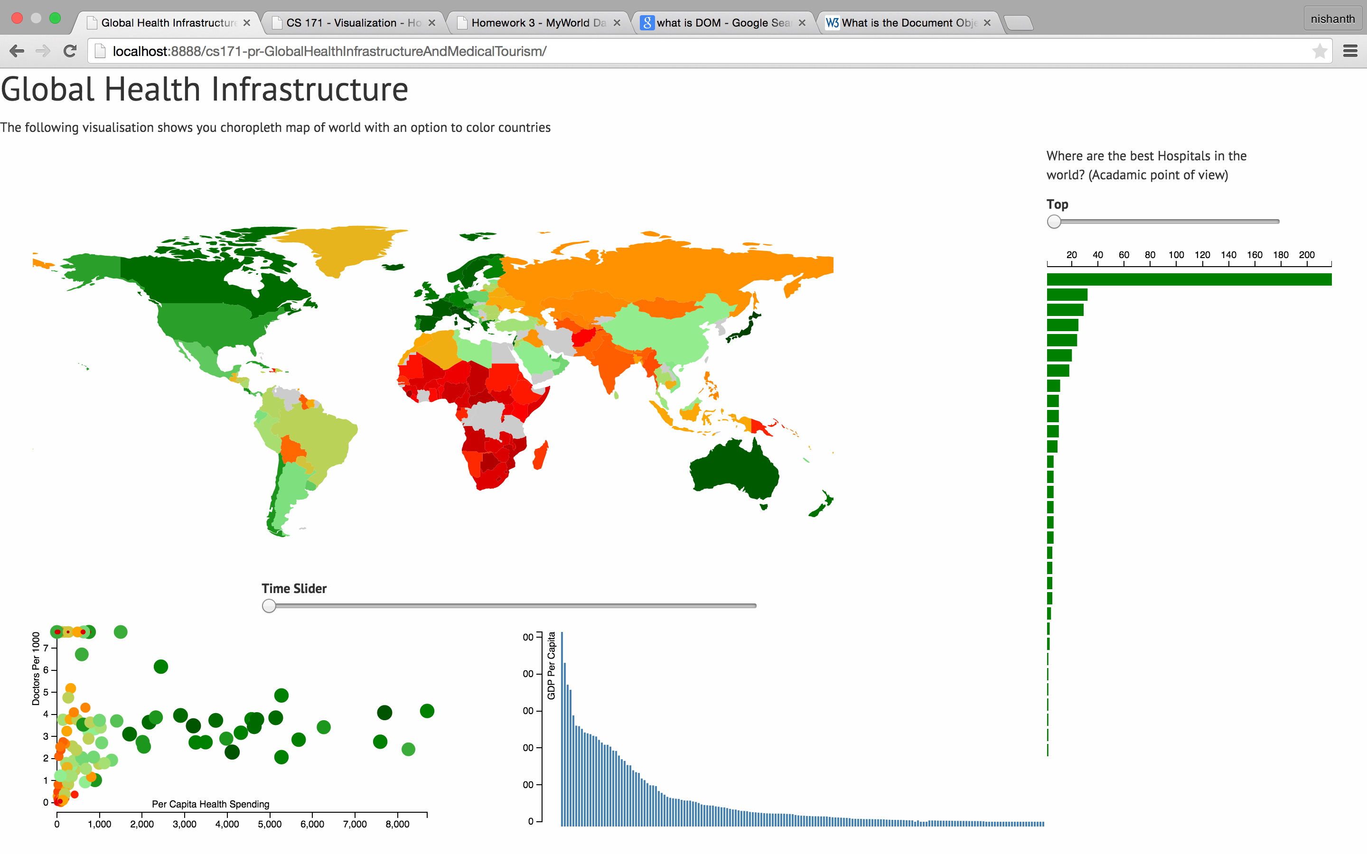

1. Choropleth map with color representing Life Expectancy
2. Scatter Plot with Percapita Health spending on xaxis and Physicians per 1000 on yaxis. Life Expectancy is coded in both Radius and color of the circle. Same color coding used as choropleth map
3. Bar chart with each rectangle representing a country and percapita GDP on yaxis. Brush is implemented to select a range of countries.
4. Time Slider for visualizing the change in 1,2,3 over time (1995 to 2012)
5. Bar chart representing the distribution of best hospitals. Each bar represents a country.

**Final Design:**

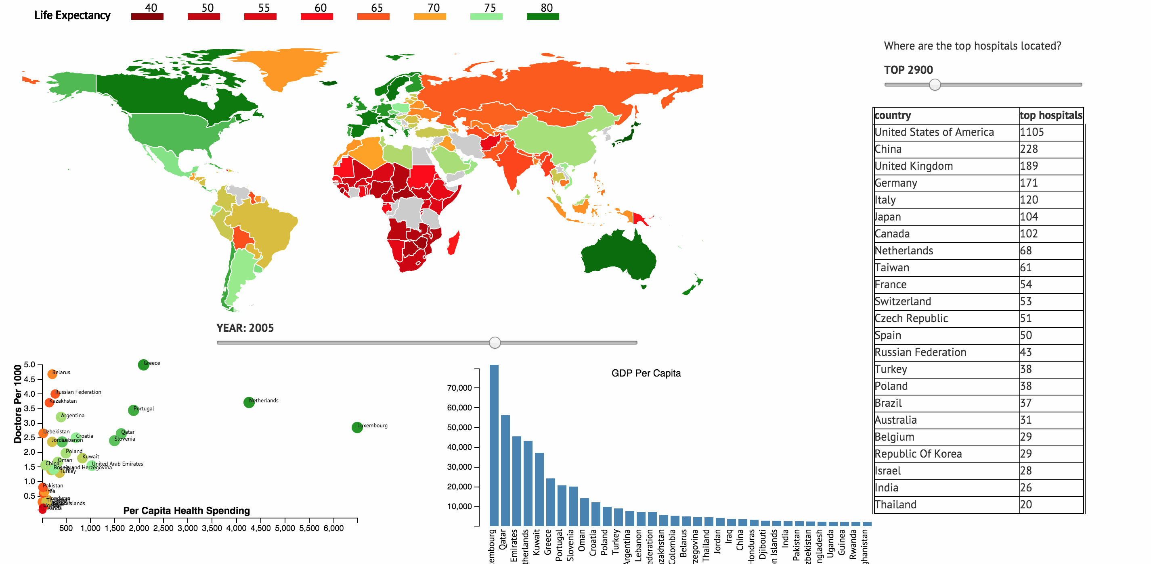

The only change from design 2 is using table for showing distribution of top hospitals among countries.

**Implementation:**

**Choropleth map color coded with Life Expectancy**

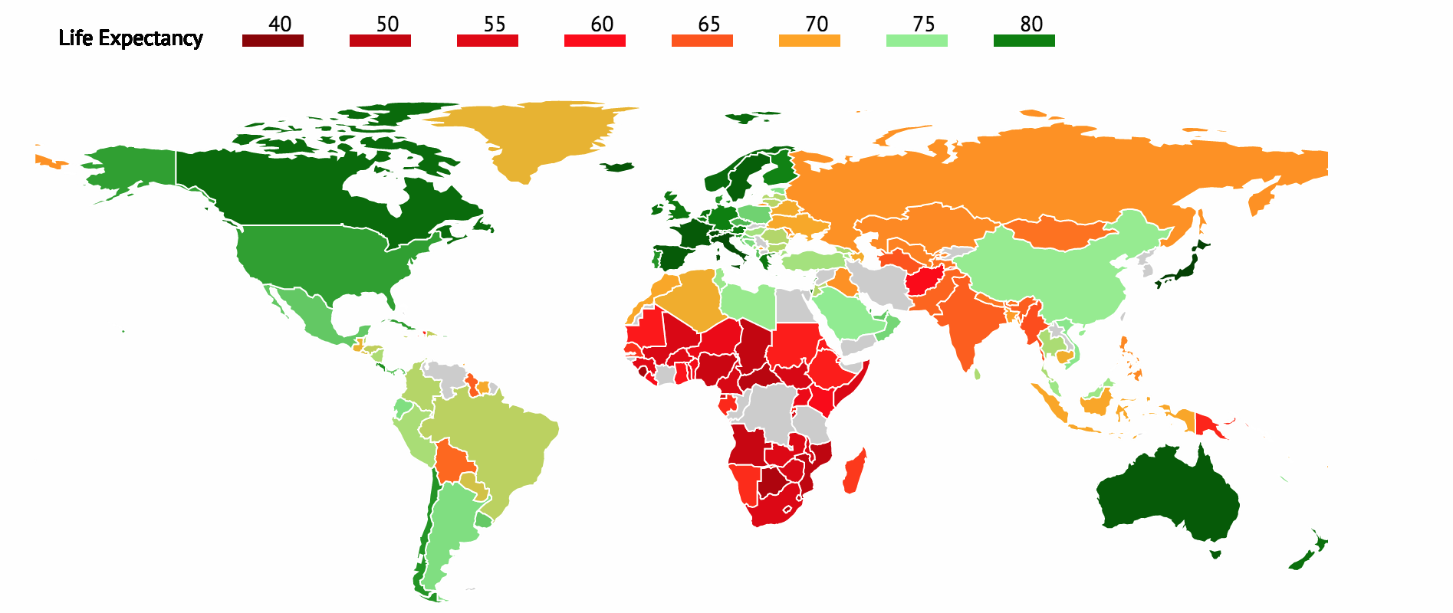

**Slider to select year from 1995 to 2010**



**Scatter Plot with brush selection**

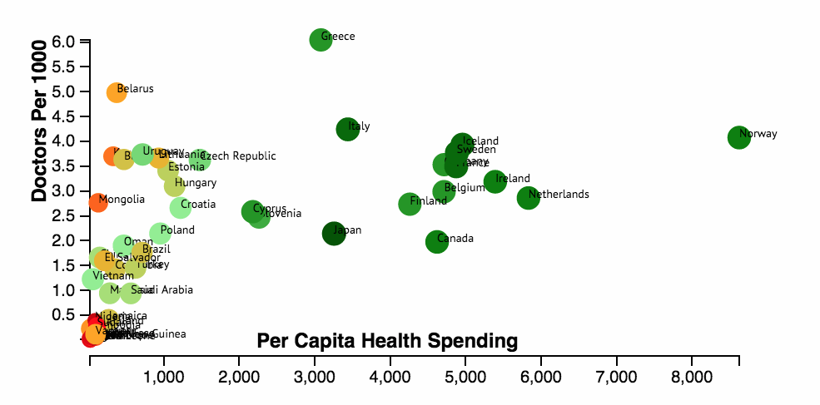

**XAxis:** Per Capita Health Spending

**YAxis:** Physicians per 1000

Life Expectancy is coded both in color and radius of the circle.

There are about 200 countries, So the scatter plot is very messy. We need a way to select countries in a particular range of GDP.

All other views will also display around 200 countries so a 2 D brush is implemented on scatter plot to select countries in particular range

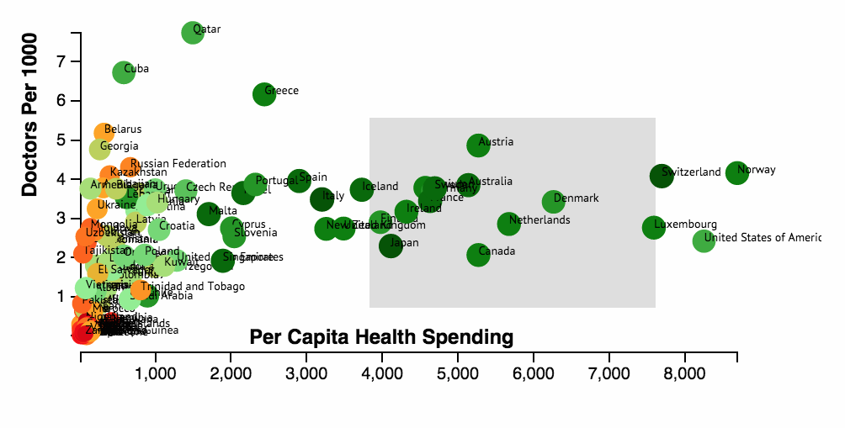

**Bar chart with Countries GDP with Brush Selection:**

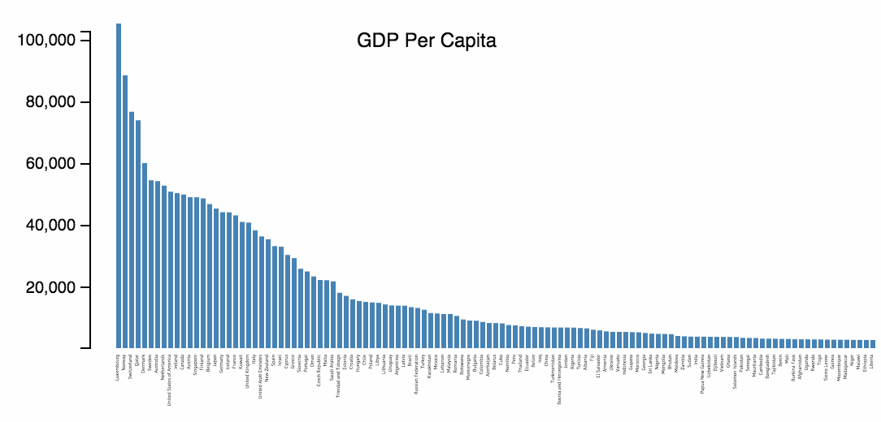

**YAxis:** GDP per capita

Each rectangle represents a country sorted in ascending order. Brush selection can be used to select a set of countries in a particular range of Percapita income.

**Brush Selection:** All other views will be updated to display just the selected countries

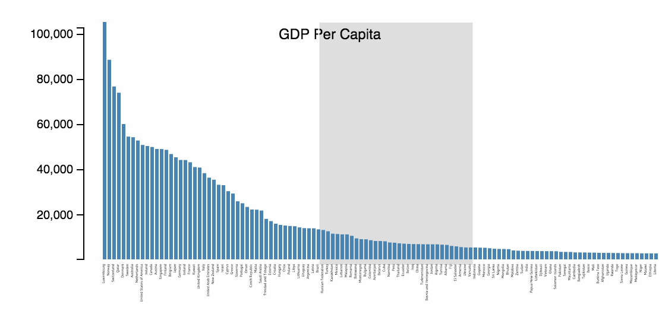

**Distribution of top hospitals :**

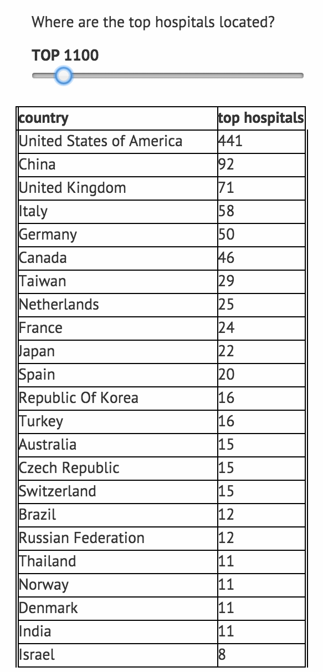

This view shows the distribution of best hospitals among the countries.

There are 16000 top hospitals in the data set with ranking 1 to 16000.

We might be interested in knowing the distribution of maybe top 100 or top 1000 etc.

So, I implemented a slider to select top N hospitals.

**Brush selection on GDP Histogram:**

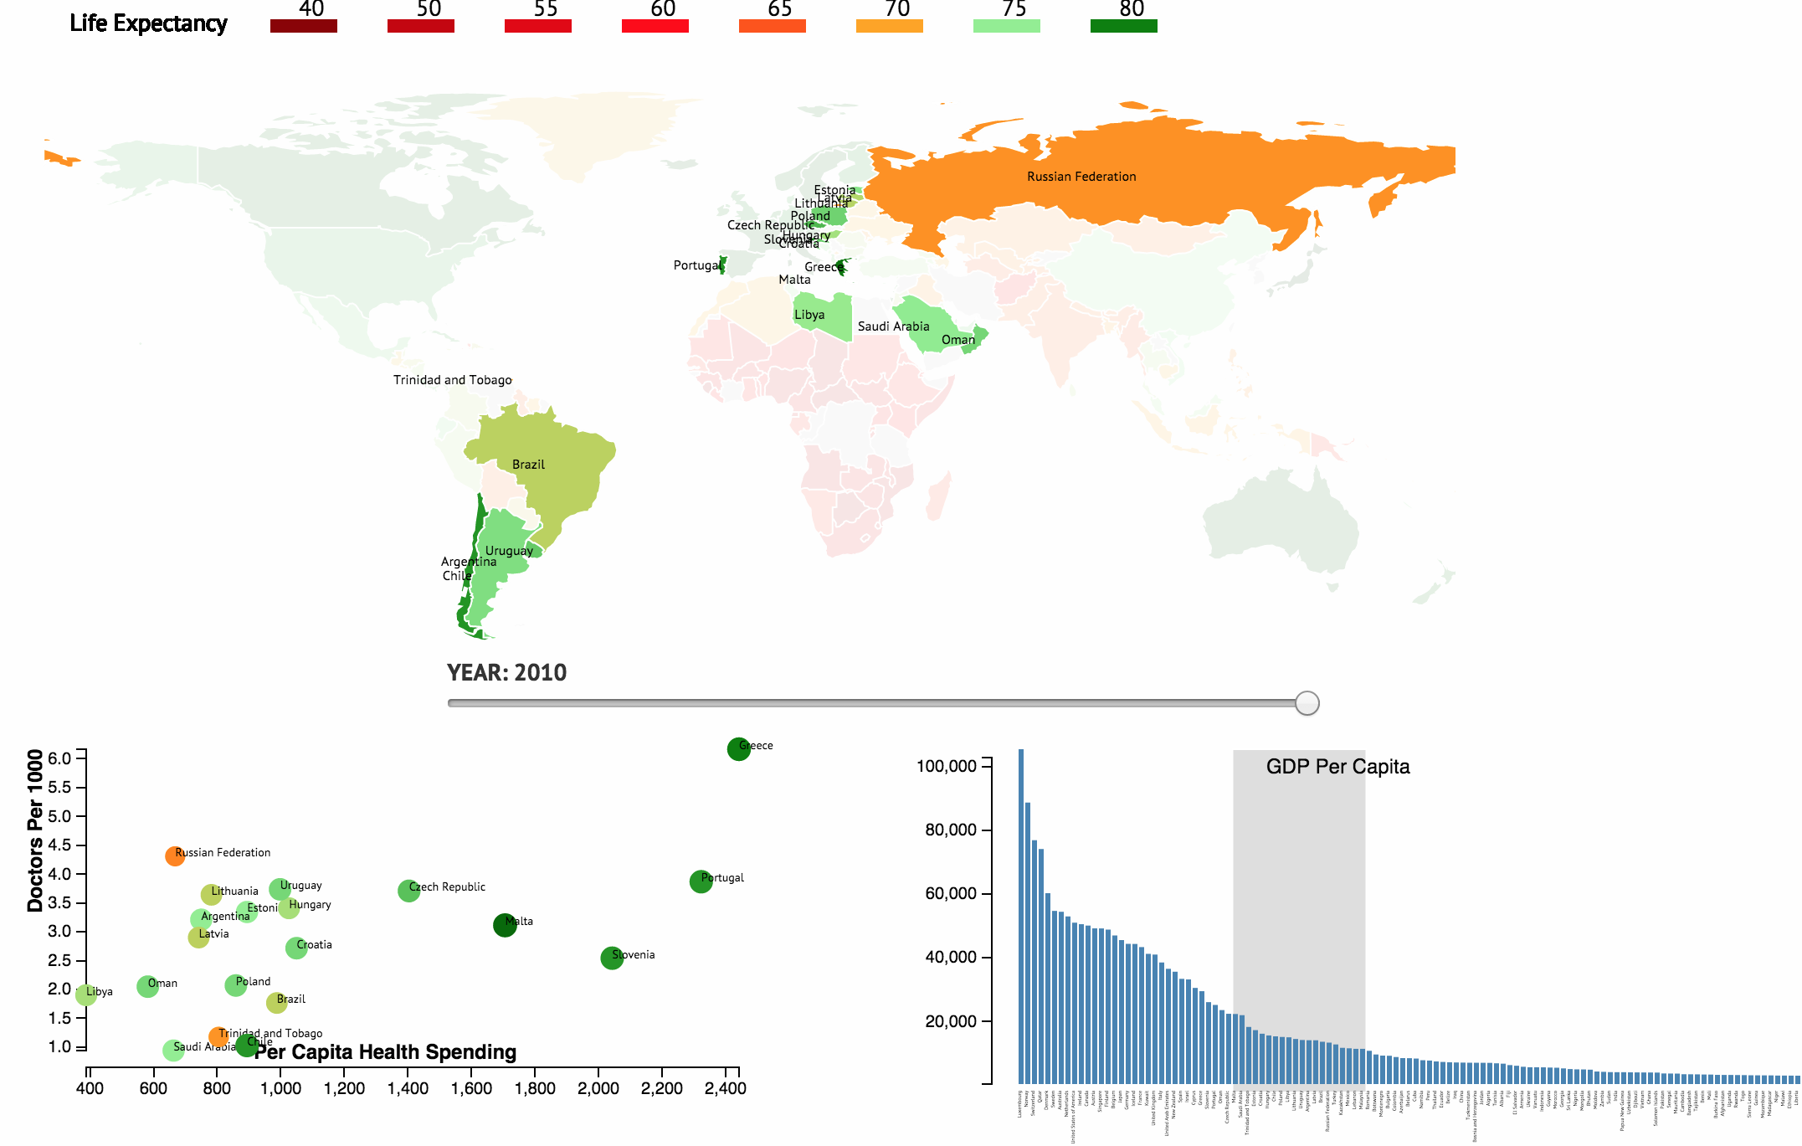

**Brush Selection on Scatter plot:**

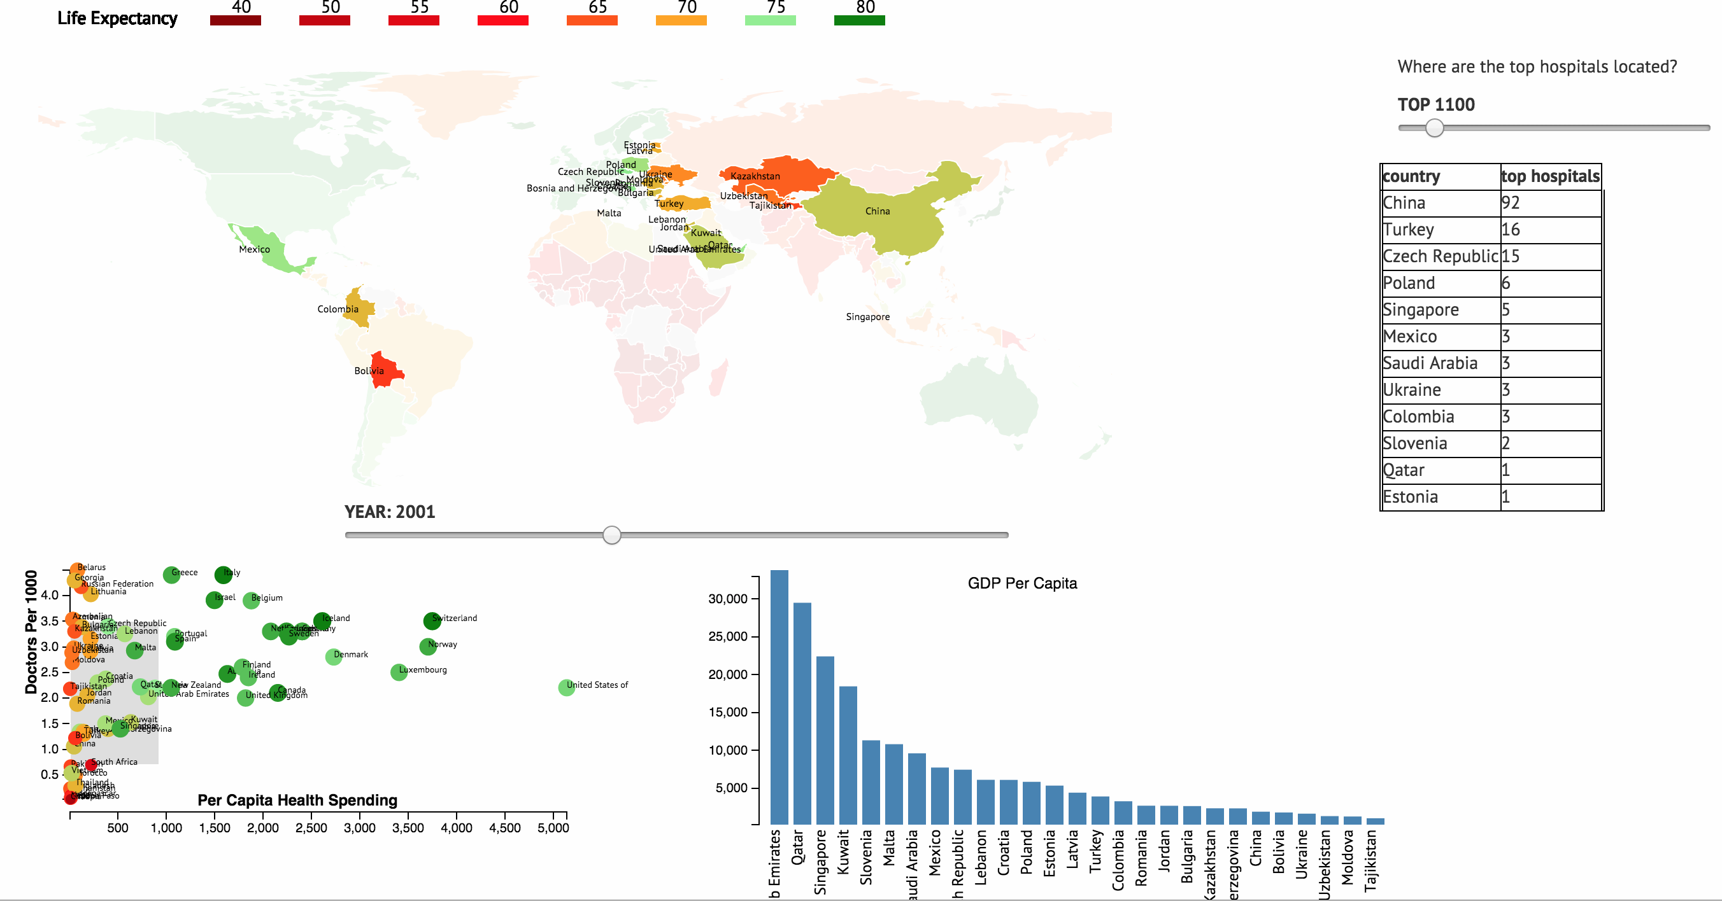

**mouseover feature:**

On hovering over a country( choropleth, scatter and histogram) top hospitals in that country will be displayed.

